**Steps to extract Facebook data of particular user using Python Script in SAP DI**

**Login into Facebook developer account with your facebook user id and create one new application.**

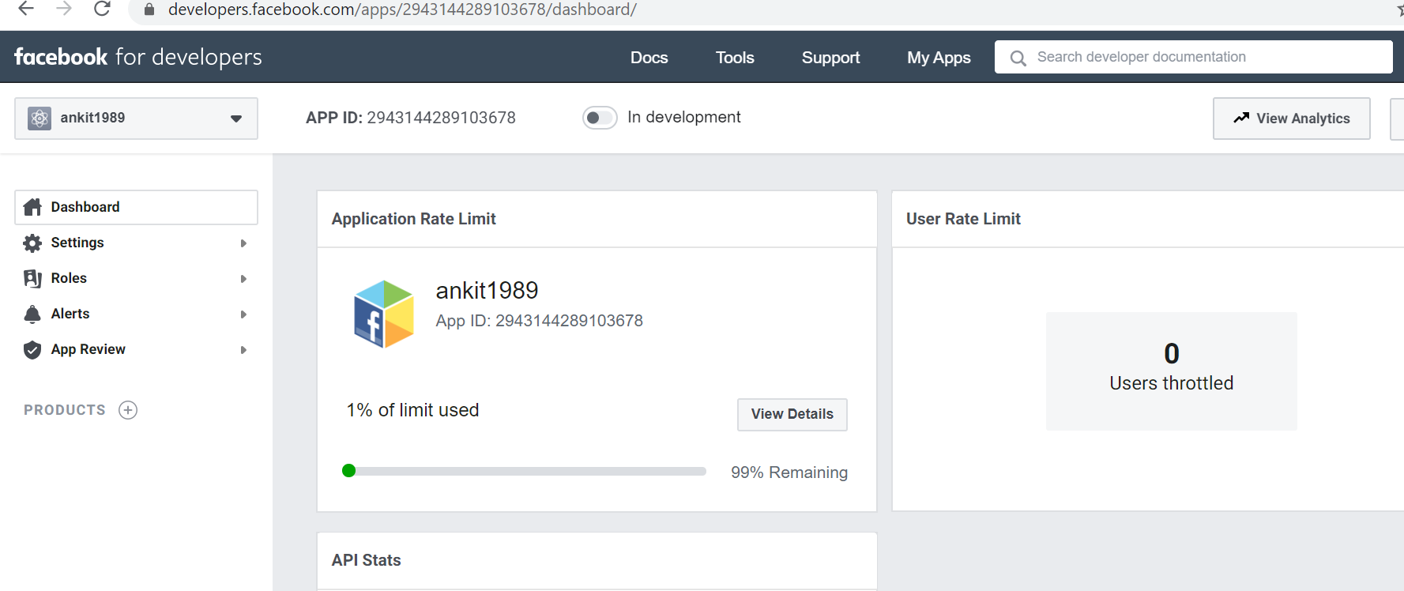

Then Click on tools and go to Graph API Explorer

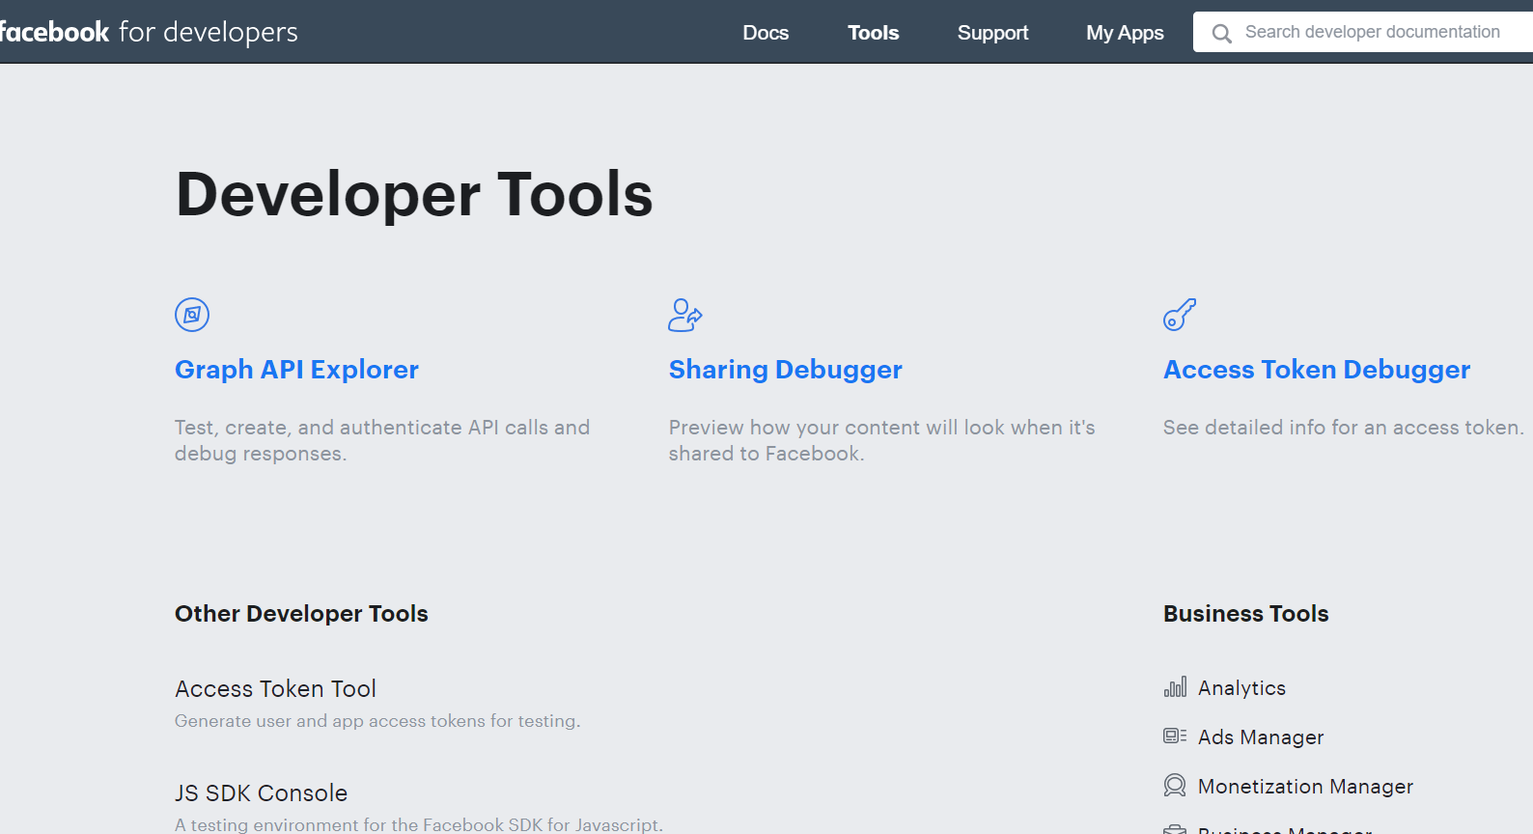

**In Graph API explorer you need to generate access token . First add all the permission which you want to display while extracting facebook data and then click on Generate token.There are various permission like user_friends,user_photos,user_location etc. , select out of these and click on Add a permission.**

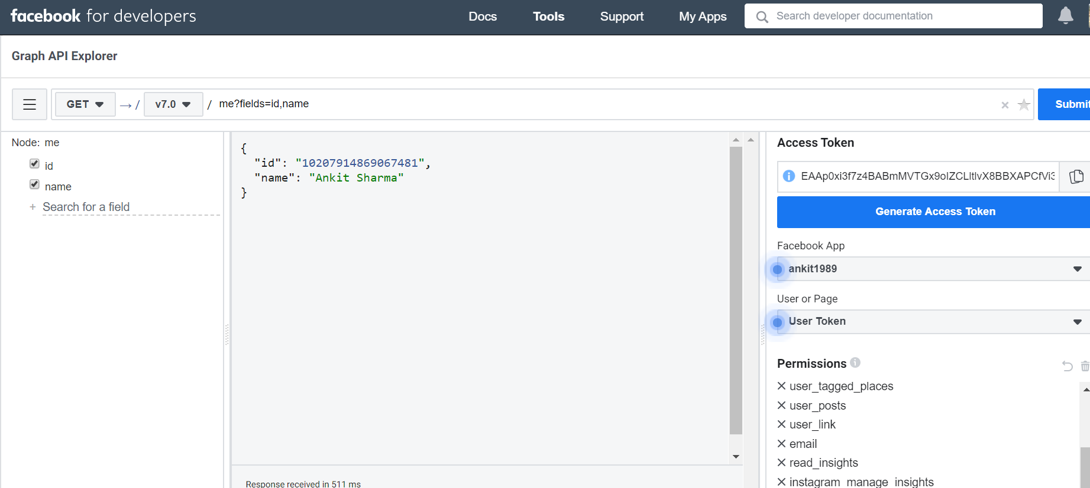

**Graph to extract Facebook Details**

Need to create custom python operator to send request to Facebook Graph API

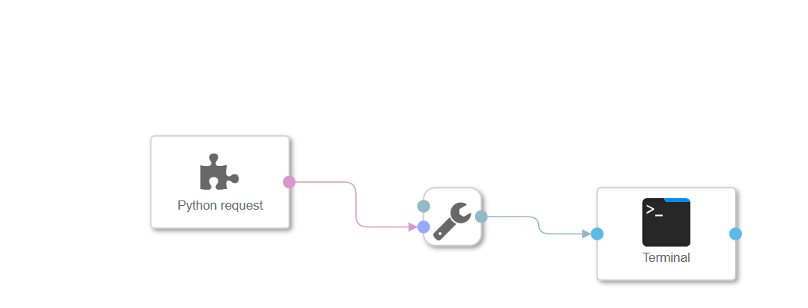

**Python Script**

Use syntax mentioned in Python script to retrieve the User profile information. In the script you have to mention the token which you generated in GRAPH API explorer. Also note: Token will get expired after every two hours , so you have regenerate it again. Howerver you can increase the validity of Token using some options which you can check online.

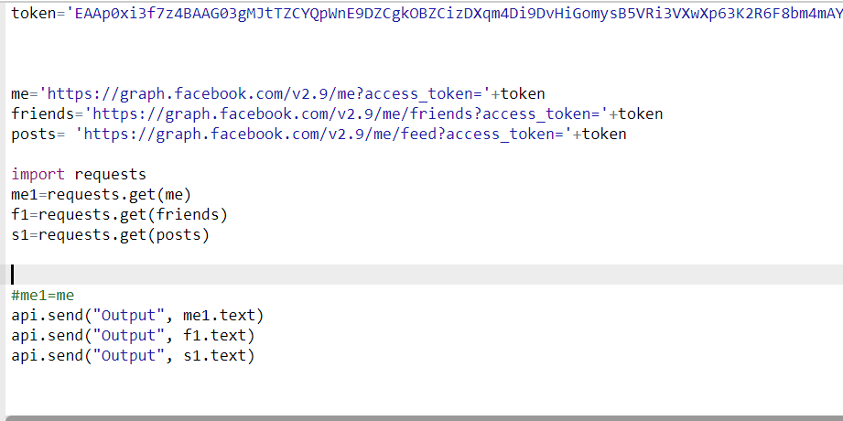

If module request is not present in current Python library then you need to create new custom python operator using docker file .”Request” Function is used to send Https request to server.

**Output**

Output will come in JSON format .

